Generate OTP :

Request :

{

    "mobileNumber": "9866570753",

    "otpLength": 4,

    "channel": "STM",

    "mode": "SMS",

    "AppRefNo": "111"

}

{

        "data": "eyJlbmMiOiJBMjU2R0NNIiwiYWxnIjoiQTI1NktXIn0.LZiFqNKNZvdMGl2pd4I2yo04u3KMht16jdY0T6b3EJaZWYBk_oQ6Fg.aFz_kYNzKHcT7F-C.ohaNzEFwawd6I03N_3_QG_SxMDlQ3Yae3iNB9ulLdMje9MGiD5kF-yZp7HXL2YQbkm2XRpRESflw8G0bt2HHswyCteuIthktWs_LB5BTO8poe7O1qC3ZPgZc78NLxhe_2OkZLLWRq1V9GK4ey8uHXcNPVhv0OiitJ-JpQEFLyfc.SaNrSc3sqfKk1YK1M0cz-Q",

        "key": "eyJlbmMiOiJBMjU2R0NNIiwiYWxnIjoiUlNBLU9BRVAtMjU2In0.U_Ac_FkWynEoTf0ksgJtxwCtf0DFhQukkXXDEabTFtyXJP6_rAsKfQDvLOsT_ac2rAHZNAg0h6nAsW6A8EiOhxWa_8DZ6yTEK5wHLJJkl076fPoEIa25YIPREtbGFXO7337-ztg1zTTUZ32jwjgoBmQ1VpKtsPqL2aNu-B4OMk6U_mOeBTdDIAGV6Q_1cbWGDd3BTxK8Mr-xY3UpMk1zE8nYY5In4PQkhlYHQoD8LBcOeXDpabaQjqzD6KxaLT0L3EzGUhFgKm_KJ3-7BsWOlqPvjmX1SG4GhYjnaIE8lXQ9IWYc5AuYXjFyEe4JBQXhuzYqGMeTkCypjUdrGlM-sg.2ctWfmX1U1JNSv1S.1nbn8uTrzuR2C7pwJr_aPxAucEnpkApJUDZ8ISChE3MmmOSlNZjXjwBGe2cA59Xi2gMCHUPtaHCtdSqMa8q2xA.ohMGJ2mj1jYw3Gt2vZX_Ug",

        "bit": 0

    }

Response :

{

    "decryptedData": "{\"responseMessage\":\"OTP generated successfully\",\"referenceId\":\"f1d0ef6a-4f33-4fd9-b90a-c0906e44b2ee\",\"status\":200,\"timestamp\":\"2025-04-11T12:36:48.251Z\"}",

    "aeskey": "efd494e4ea94576cf8e87aec0573a13af32ef6164c8b9f5bd542049d0f2dfa8f"

}

Validate otp :

    {

    "sessionId": "6258f731-d03f-4bc5-8ba1-6cdf31d508ce",

    "otp": "8d969eef6ecad3c29a3a629280e686cf0c3f5d5a86aff3ca12020c923adc6c92",

    "channel": "STM"

}

{

    "data": "eyJlbmMiOiJBMjU2R0NNIiwiYWxnIjoiQTI1NktXIn0.W_0I38-U1_xTE5XYwdXa7Xg-yZ1__kkNN7GE7cT09zqu160BNgAwfg.BFCH506BIlrUf6p2.rAVlStqfXW8g0wLoukRPovRWPhAWBait80Dfuo9lr6vsJcvrCm0XW7HNb1h-LxS7Vng8-yJQ-6z1uqzkesAiN3oKPb9MArEuUylueltPhYYvubr2roNGNyb6XTStyz70YkM-2YZpzVfZPBk4I6gl9-8pHwg6DFQOnSEagala6_H-IPuQo8eFWA5_eLofWU9-Yi_aNKqXuN8limQwJEMYLBrSWdE.etgEwgINmbfWE9Y740AuWg",

    "key": "eyJlbmMiOiJBMjU2R0NNIiwiYWxnIjoiUlNBLU9BRVAtMjU2In0.mgAhgxEk7Mp-T-EmvMPLjKJzVvI-3-9co5cSz2rOQl2UTOAfHIvu0ofsOdMr5uWExLgd9GYbgeoWER8tM4RyXLuIDU4eoim37477kxb5NmydqFNQmda2Rra_E9oR14U1d3viIM0RoguEYeRoPdyPGIGBsAJCY2aVR_3zwoNQrz5pfNJMZrUMqcL1gi58Ok1xFLvTqpYffiPYr671jA3C-XU7TH7iO6V_EOA9H8ilZ1YsUuEurI7HTeR2yfkbtDMNfmTcOPC_UuIYPklzatqXilr9nnvWqT2pw5MJhYENs9E_7u0ZqoN3iDmUv8_JqI_-nhwHdPWlhruZnouq7krZXw.hyeD-5nEh2jrQcWd.idhyTN6V-s-n1maBAiETCY3yyOvElMsuYcN71F9U1HhDb8qc5HD2XS_lMUn2K5or-z5EibE226bUQzHoVKaZPQ.iWKBV4FTck29_N5SxS6sqA",

    "bit": 0

}

Response :

{

    "decryptedData": "{\"responseMessage\":\"Valid OTP\",\"status\":200,\"timestamp\":\"2025-04-11T12:41:12.474Z\"}",

    "aeskey": "ceabbfb2d0f98317f2f7f4a30a9ea0b833bbfa94334db3cbd213e296b42bc553"

}

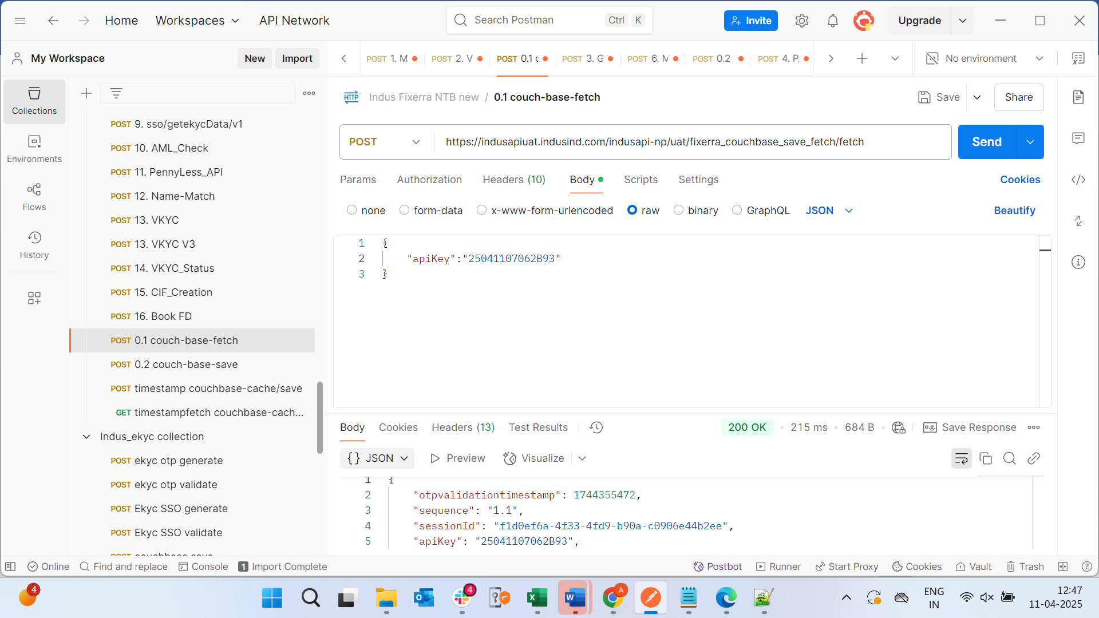

Customer Enquiry :

{

    "phoneNumber": "9866570753"

}

{

    "data": "eyJlbmMiOiJBMjU2R0NNIiwiYWxnIjoiQTI1NktXIn0.5Jvv5bOezGDejTenpECI9_rlqoylQqXz9OFr2I6ReFRe4Lb9RJfkVA.HPuFtSTuT7-F0FZ5.n5jHz7K8mKgjOdYZrOw-KpaV46P34oLHzfhV0ZDy5pW3NXIGPA.0AmZEOjDEkN3oa4AzuOu_w",

    "key": "eyJlbmMiOiJBMjU2R0NNIiwiYWxnIjoiUlNBLU9BRVAtMjU2In0.uw7R-_0PkjaC0NWiqEqQDv7z74HrBIR9kPvblT3_rSNPbGSdnVxrp_WjeVqpF6yKX9jKwZTRZ3w3NBokCC7siSLguKZSJW9qvduo5W_6MoMjkZGSKuQzh9-HJmqahJj85kml9aEzZxNwT6Ds7TTKe1dYpp4nislQirxs2-NkhsrrJ03Tkp4z3IzD67_wtfj3e-FkDOzNfKfetj41mql_RmswpZKJfEsDb-YtLHR5coEJeNSLMNyovN8p3ki58Y1bBZRHG4ABU-jJyXWhN3wl4rT_GnOhos_5Zpm-Fu-vjmVAVMHZcnWF8pcbQEBqMeEGrrmtmdCYgsQEjySBbq_5KQ.aaASe_QeBOvBoJAC.SSXh0feLUd8yPHdZu-0V1tZwVyiuhwkPp8AcVTfpU7cF2bwSPrPmSiME6XssASHqm5KAFEa68sj-Hq5lPSaoag.4UH1o8EJFdLLNNt9Lmhc9Q",

    "bit": 0

}

Response

{

    "decryptedData": "{\"errorDescription\":\"No CIF Number linked to this mobile no\",\"success\":false,\"errorCode\":\"ETBC001\",\"status\":\"400\",\"timestamp\":\"2025-04-11T12:48:54.050688\"}",

    "aeskey": "c8b1965737f55e43893137a1df100ba5ca2f9184d16d546563c7552467a83faf"

}

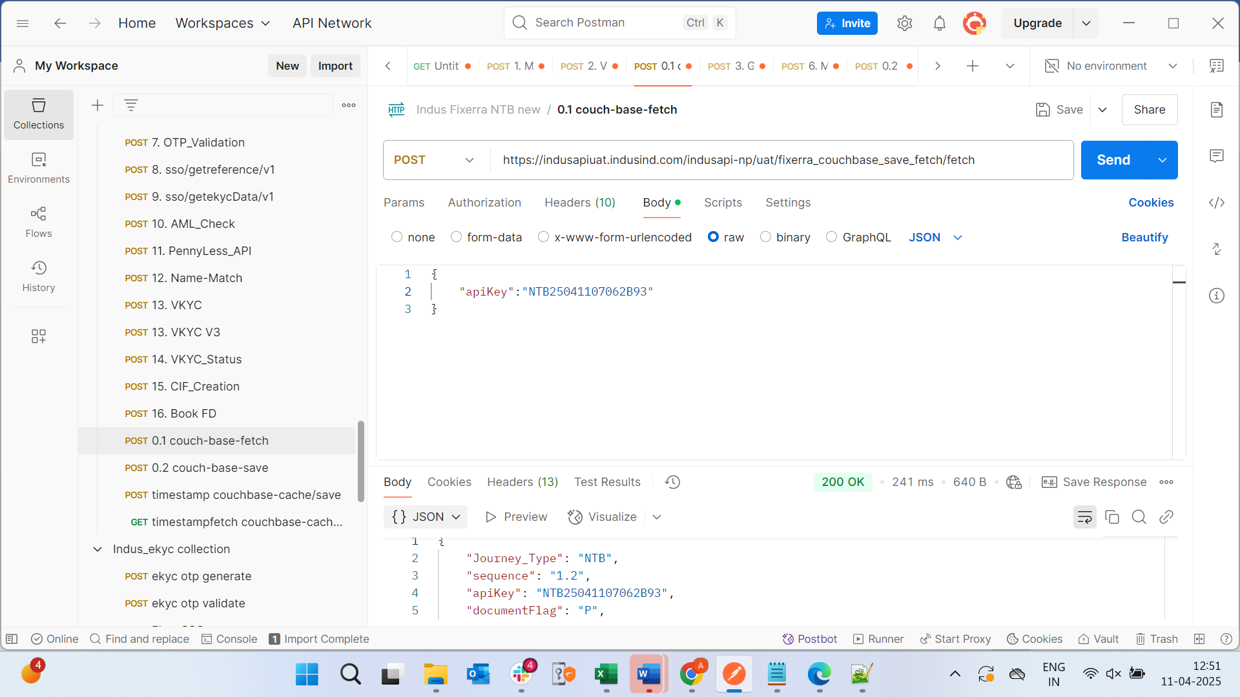

**Pandedupe api :**

{

    "requestUUID": "7UTTD88GDG8DG",

    "channelID": "STM",

    "category": "Individual",

    "panNo": "FNXPM8011G",

    "AppRefNo": "SMS27"

}

{

        "data": "eyJlbmMiOiJBMjU2R0NNIiwiYWxnIjoiQTI1NktXIn0.63PHdbGXliOI0Tse_8hzD6NecmRr4wPc83LvGW3g8U8E4K7VSjDvhA.K81VB4pNoBDrS8Mv.CfU2-UMJj3sWE8U5rohnwvuF_8zmVnhpM-N2FOkAtFzccAhOzd3XHKo824GQE_idePtg67iT8Wh1guVlWxRigIdp3VSKG8uBKQHSQGKiHKubVfb4PPlSNkTbFGMljX0JMHhDfmqYKTtn3J3_N-dB7BqQKh2ZlHTBumaKK1iI4kMyzlphZyDbN0eDtD1ee8RUiWtWUnduhkM.9fBEUZwoUlTohVLu-Yc7LA",

        "key": "eyJlbmMiOiJBMjU2R0NNIiwiYWxnIjoiUlNBLU9BRVAtMjU2In0.h_vmyhxgz1d1qpD_TuRbaTLW8BsWUbNsZkQmWm_Pi0iC8Pw2WCQBJELr-CSKrNBVHV23pTLY8BjNuNzM0m-hQWk1zZR-CjX6JEU8Ebad5vks_aHvbbaPcNbe8yBXZXdJpoOB5fOhLahZdCVO850NbbOk4mv3J4Rry9IEK5QDDipDCfN97UwXVEYriIwP6X5oBxoo5zBrVBpShQR-6sqkPnBcaPHxsxF3e48lBD6FkhJX7LcLbCr_Lcy9PNG9KkHBEJf6e_I4_XQ9ZYIJVQQNhqx31Nj5mI0tNjcDeLmsi1hdAxZcDLwldkL1PqbbQwzVAGa6FcYS125CrY8NhoI3Wg.8LpbRrM9TC161hWp.y8LAV5F7ICRlIs21oUVqOx1iwrYhoLBxzGaG54p1-k7SqxoiUEsUCUFG-gE2Tfc9Kpo3oeJP6duVOgZtMxYe3w.Jd3VIrBAwDTBZ0V8ExTQjg",

        "bit": 0

    }

Response :

{

    "decryptedData": "{\"success\":false,\"message\":\"No details fetched\"}",

    "aeskey": "e71abe9e8734577f1232e5f42ad295caf16d69f178d6effe0c87ec9ed6189591"

}

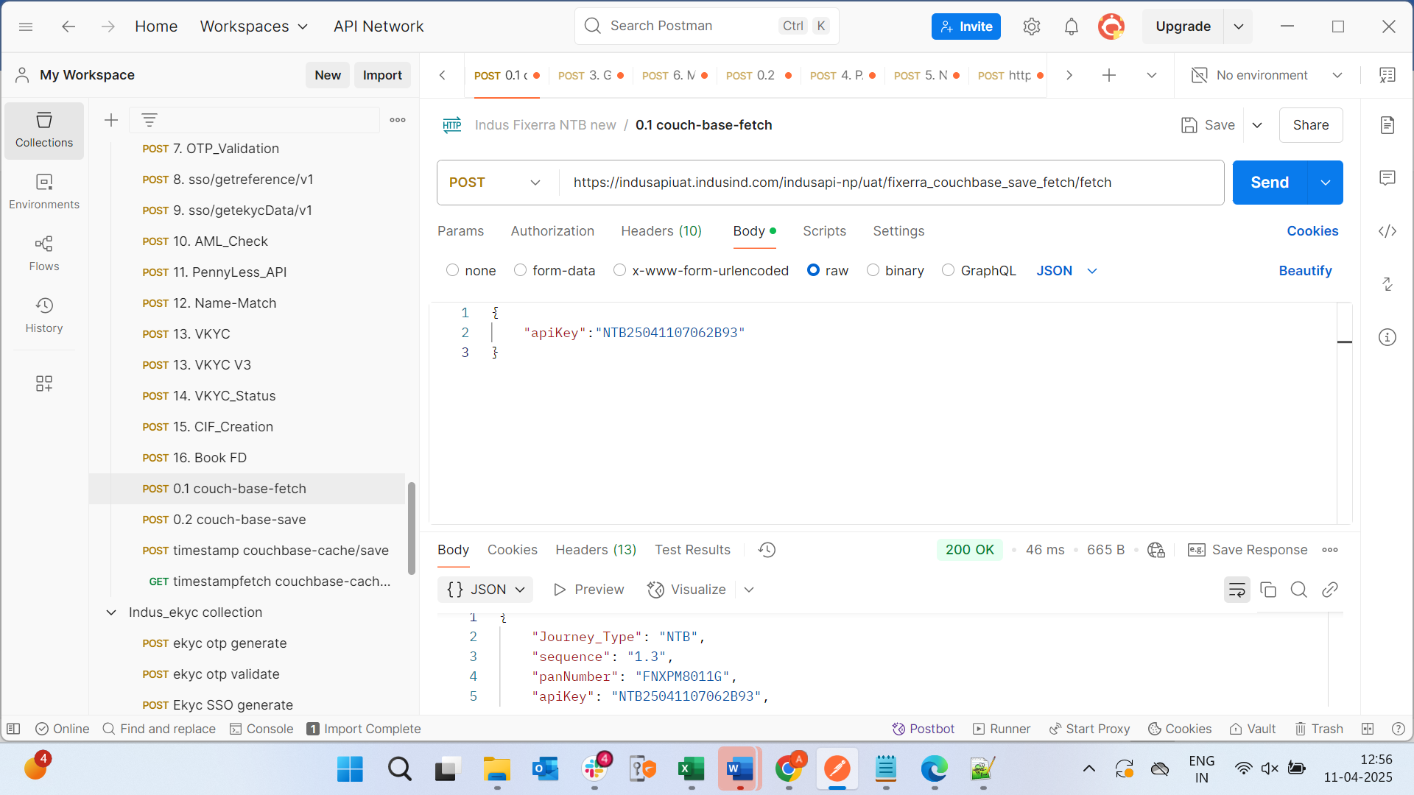

{

    "Journey_Type": "NTB",

    "sequence": "1.3",

    "panNumber": "FNXPM8011G",

    "apiKey": "NTB25041107062B93",

    "documentFlag": "P",

    "mobileNumber": "9866570753"

}

NSDL pan verify:

Request :

{

    "request": {

        "header": {

            "channelId": "COR",

            "requestUUID": "6333qe3we923168782"

        },

        "body": {

            "pan_verify_req": [

                {

                    "pan": "FNXPM8011G",

                    "name": "Mandha Akhila",

                    "dob": "01/02/2001"

                }

            ]

        }

    }

}

{

        "data": "eyJlbmMiOiJBMjU2R0NNIiwiYWxnIjoiQTI1NktXIn0.3pD-fSGe7Y4MOd5U16yMFmu9EzG3wMGdWjsbAIUCsGIBZ_BlDZuaHw.-unWZ90TfVwMmfh5.kftmtEw6eGUK77DEtDRNhnqeR1tExJI-w0i7kjP7bNY0bKu1uSg8h3xMX2A5uCHJsaHXHrsEB8vh_JGSB8Y9e_TfbxbINjYcQRjfSUi7h-TJMOwRl04ffWkC890sBKOFlEGZJT8PmdJn5WISZU_SjHf2-XmEFGJZt029XHZGreQzXxYRrKAOhA9AiwPoMHfzqHBOt5KohqMp97NzY63LSGEORCx_LgRnMD-4soeWNQHU_LwKE4mOxdLl9M6wIdsAPGT6Z0pc_lu5NrdW_zmhE7gwECHD5avlsn_e688VucpcQl40-M-oVZUkcX-hoF33Oo1qrNOlW1tGwlqUaO1HeISZI5Uxvs9filfD9JPEcNlqOzc-lp-THcAcHLSwIkR6jcPIcqGPdjlJBCFv9Kd0JpeI5NxLpRppPtRVednTI2jf_rTG-Zrcx57FhB8qyEfKO5EgFDC0f5zGLn--STCu5ZOjNIsK4jR41t-N7KGymRcMkJRxw1FTa-Ws2hUpfGENkauVbvHrPg.2DZRWp9562VfqtRKulalYg",

        "key": "eyJlbmMiOiJBMjU2R0NNIiwiYWxnIjoiUlNBLU9BRVAtMjU2In0.rbeaga5adUstY8c8VAwo0xqv8qYsZhaGlGxrWiBt_bZpMbsPAIZVxlrEVn25cLhJtq8UbmIfrws4zu39bCK5-doZ3CaLavbEHeCVqAoXliAnMcHfgmyW2MubpmIoBCmaa1W9f0Ikf29dzay5srl9ZCC-QjhrrKD7HbO2igfyCAiDAA7yajIuWblqnJmtwEsEpFtIlB8Z2URTXaOCgJnFCKddKENVV4NSWA3R4coCTx10ePYfFdFD5oo-5-mtQS3ZC8_a6oL-beGJqEXBm4Skibw5nxo7ORROq-VgT9FCZjJ1fwcR6iw23qOuJEkP57PuIcEcTEpYhm3llf2KuuL_IQ.KZ18PoTXtdhWKP0m.RXY7luHo-g_aO79Hfa_EwJlXTK1eYb6pgTv-9E-ueaETKNQuzHyZ1Z7YO9ks5mx_YhSmnL_6NmgSUDlSVbxDHw.k0FO5SPTlA6A-aq6MQvsIg",

        "bit": 0

    }

Response :

{

    "decryptedData": "{\"response_Code\":\"1\",\"outputData\":[{\"pan\":\"АААРА0039K\",\"pan_status\":\"E\",\"name\":\"Y\",\"fathername\":\"\",\"dob\":\"Y\",\"seeding_status\":\"Y\"}]}",

    "aeskey": "cfa121a05103d08cf488c5c77c04c3d5a85fa7000ea5b95d43e8223eaa1d46e8"

}

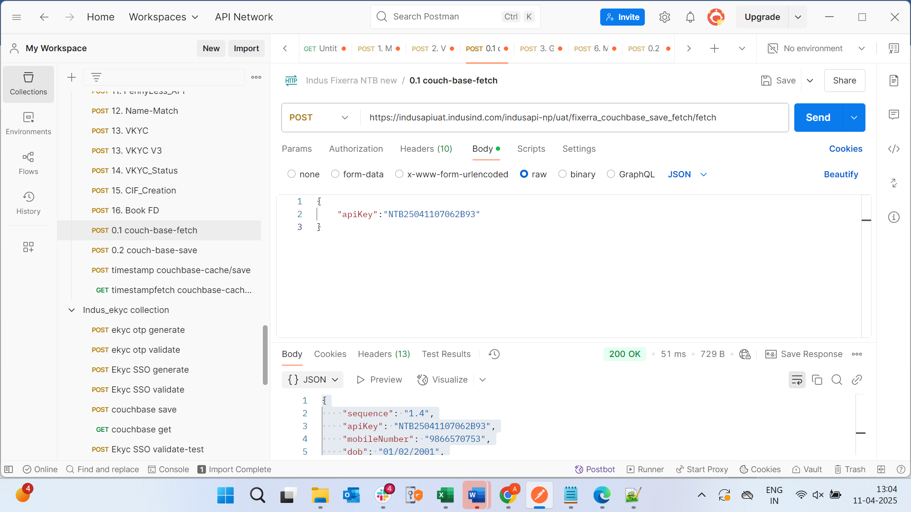

{

    "sequence": "1.4",

    "apiKey": "NTB25041107062B93",

    "mobileNumber": "9866570753",

    "dob": "01/02/2001",

    "Journey_Type": "NTB",

    "panname": "Mandha Akhila",

    "panNumber": "FNXPM8011G",

    "documentFlag": "P",

    "panStatus": "True"

}

Mobile and email api : **Generate otp api**

{

    "mobileNumber": "9866570753",

    "emailId": "akhilamandha046@gmail.com",

    "otpLength": 4,

    "channel": "STM",

    "mode": "SMS",

    "AppRefNo": "111"

}

{

        "data": "eyJlbmMiOiJBMjU2R0NNIiwiYWxnIjoiQTI1NktXIn0.F5bggIMK6EBDrQIzWU8ZUJDWhz-BpxGRmqTdNNx10HaBeoAN2hbwDA.m8ZB9YXDiX-7me2V.FNqc0f_3EB7h1dcMl1Oi5NxQAAga2GQH5R3QPZMN1TfT6ge05OmRepw-jS3dx3VIHS-sS-qsQoJKB5X2PVX05Vx874kmomzcDdUXyeUaUQ1B0YlVPJG0fzOnFGDYT7Sf65SPGxGlf2zzmxrtTlGvHtcGsM6XhZTdWEVHtRA9oTPxi-e9-qIBcBnn7XSWa6BKWwsjt9Zv3_X-1kX2Knwu9b8Gx_PVUZBky3ff_yE.DvRZSAUVPd5t_4mTxdpwcw",

        "key": "eyJlbmMiOiJBMjU2R0NNIiwiYWxnIjoiUlNBLU9BRVAtMjU2In0.eLaDHWDZNLl8PJuQMCa39WWQ8LApjtVkG3l0hGApSFJGGAnTkrHj8glrjhneky-oMqv7q7nIfWMyycPOiG3Bl2OJbk4fFQwdWF8AiJdKttW-XKesN1S9drN31Twk8TT_YEdmXwKRgfqcZpM2qtYpTJEwBoy8J7cl1N1KRfD8w9tcBvqzApMgtn_O_uVkA0NRriW3SVF1mRbtq36COByXbq-FV8cvK6ufGeTvu5thCnucmrEtJVVfiwyVYYYzWANyAjzzDow_2vsmXpxnrqfqYvd_gPzMNWY6Dk8R2_Hv0uwfAHVlFdcQwVMa7zqFS84zuDdV5m4HaGZE9jdWhbdrxw.hsGsivj-fxyaRBeo.DrO3Kcoqu3P4Ughez-jn7Q67Olk81b9BqPtMGdzKhu3taK5rwbCqdSOull9x_5hwNdyO3FzFcRUIUF8pYHFbuQ.oDbjNdupwNx6gVq34et-Lw",

        "bit": 0

    }

Response :

{

    "decryptedData": "{\"responseMessage\":\"OTP generated successfully\",\"referenceId\":\" e4576548-7225-4d85-b991-b010c7ed3dfa \",\"status\":200,\"timestamp\":\"2025-04-11T13:09:11.135Z\"}",

    "aeskey": "0db7db910f89cbee8f583529f9734da4e8b7dcf1aab00f72c365ba94f4b54d15"

}

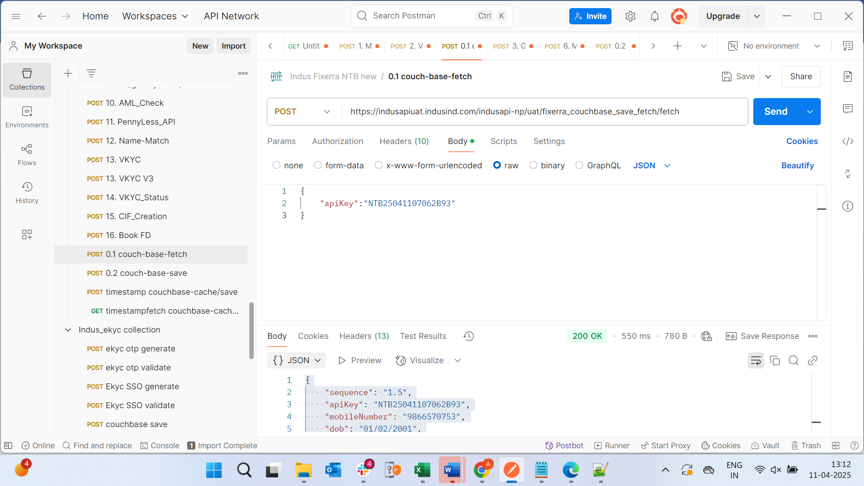

{

    "sequence": "1.5",

    "apiKey": "NTB25041107062B93",

    "mobileNumber": "9866570753",

    "dob": "01/02/2001",

    "Journey_Type": "NTB",

    "panname": "Mandha Akhila",

    "panNumber": "FNXPM8011G",

    "sessionId": "e4576548-7225-4d85-b991-b010c7ed3dfa",

    "documentFlag": "P",

    "panStatus": "True"

}

Mobile and email api : **validate otp api :**

{

    "sessionId": "e4576548-7225-4d85-b991-b010c7ed3dfa",

    "otp": "8d969eef6ecad3c29a3a629280e686cf0c3f5d5a86aff3ca12020c923adc6c92",

    "channel": "STM"

}

{

        "data": "eyJlbmMiOiJBMjU2R0NNIiwiYWxnIjoiQTI1NktXIn0.bWsLUpnZe_WITodLl1w7MliRtSqryTj5chc24BY5cAyqTcbAmmmrMg.GfrzhWryPY5dE6ml.5lcLcbXS5_DgmG5GlVP_XyCqt4U8zY4fpAq7ksG7Ausel-DZFQuAH625M7eAaVB-8o4bHBfCEvYnX8Tp2MjP-pANwuU1gS-7h2O9vhSsTOF0eksa2h2y38o4YXxS4_7whJfD2HpdSjOke3yF-fucyGm3C5zYAbVlF7ZKXDZIbEFINeC55UosSKMD26VdBC73mv12Flx84ISs5XHgWMcTkOOBaEI_bA.lofE99w3Sagmj81ladfJiw",

        "key": "eyJlbmMiOiJBMjU2R0NNIiwiYWxnIjoiUlNBLU9BRVAtMjU2In0.BsBZhg-Wi5OlkOynflinvpJLWJzHnNkekOyFNUCrB3moM8bZtGzn0kB6QbjM-sxfAXmHdzLGeI9bveBKL1V1C80UBHaDbboOEp0EH4_v8Jrml67Pcn1yUMAofcj64wbJ6XWg255ceiqmXKj8zSDpXmM4kG_wG_yeUuQHjmD3OHEISnjEkQ2bFjNgdjRY2qBiLziWbeFggIw-UUfKcVEomcNCVonDqW0zy2b3LtKkVgc-iiw6bdI5F68j3sNkKImkzIJCTa_o9DWX3_pId4-adQSPU7NvZgUsiRvLkfYAp9v5s_4xoKXmS_kQKPbHkmES91XzcV2aBv8wGKdKcJZP5Q.elAgO8IpiVLH1i7-.XysS83q4XupSaXQ1aYbHyKX8g4bDmqbUQke--HYU11YTJ8jj940TPzbdJoRMwwmuqh--wdghrdW-C1oAKeJAfA.Lq4LjAdYauYQpkXyIiDfqg",

        "bit": 0

    }

Response :

{

    "decryptedData": "{\"responseMessage\":\"Valid OTP\",\"status\":200,\"timestamp\":\"2025-04-11T13:09:11.135Z\"}",

    "aeskey": "ceabbfb2d0f98317f2f7f4a30a9ea0b833bbfa94334db3cbd213e296b42bc553"

}

GetReference :

apiKey:2504140556E822

IBL-Client-Id:f89c25480aa01ef07b2da59dceccaef6

IBL-Client-Secret:bd738788c4ce996160c9e95fb5fd7a95

Request :

**{  
    "redirect_uri": "**[**https://indusind-api.dev.fixerra.in/internal/api/v1/redirect**](https://indusind-api.dev.fixerra.in/internal/api/v1/redirect)**",  
    "app_id": "c468622a-58ea-4f0a-b102-e59cda8510e0"  
}**

{

    "data": "eyJlbmMiOiJBMjU2R0NNIiwiYWxnIjoiQTI1NktXIn0.zWg9F85whOrUpNk5HZtoY6adbZ5nQDZnj6DKeugxFVKKRgO_268qJw.wpIhOoguBdOeJtFa.As8oPilWxQNmyisPbT7Th2wXii7KHWtXMaUDJ2EgUWOTaoKB7OvCLp4T0rIiQVDVDjy8HP5RGo1FztcMVBxNXYRuCzQ1158zZLMVDuklr_lFO01gqQdRahz1Psj8lxd1iqstI-jzo7zjcj3z67BQ-0tERijCBRAW-GvO0Psg2NnIXTHQPwPuCxp9RYqMaSo.UZmgSHoqzX4BWj11NM2CMQ",

    "key": "eyJlbmMiOiJBMjU2R0NNIiwiYWxnIjoiUlNBLU9BRVAtMjU2In0.l8kkTZeTudp9VxIUFdnesDDkZRlwCPS1MdbaoHoKYG19q-ujAA7F_NAh-yM8Ya7YpCOWZFgmU1H1B1Quyp4Sm35n5lhZ7d9VbUgS2D9vrW8xERz_QI0fIirgXcogGD-yBSFi2nbpNg0Zj1OxiJ2CjRroRKvzXKN1JrLlWs0WYU-ALTJ9XYuGq8MkG5h2RhYMKFYJJgFjFIcneeDHpoctTZBSgYIdd6iX7m0AAqmPgjdMrtnI6IwQfoXprFYWRinWUYI6P252I_eNDktHLn0raiFXTt-TNeg6YwrcMULIMbTWkWswP0gNVVVzqYfsWcxcOIRhYlczXS66j1vskqqJJw.YTAqklgeKWJdARuW.iYhxCf0CpWGrQV9i6jGhZ-XTitZZjULF5vs7y0S-bnzyF_H98SPIUXpnMkeCjtgsOsAwCzk3k8v8QXDfUi-8zA.ODBC6lNQZQxHQ5HVXi3FqQ",

    "bit": 0

}

Response :

{

    {"success":**true**,"session_id":"8830d6e3-ec8c-4cc1-aced-51e46300f207"},

    "aeskey": "6fcda73f90f04325fc54efe6faa99674abcf5f7bd0e7d3adca9f4073bd52ccb6"

    }

**GetKYCData : hit this api after ekyc SSO byotpvalidation ,ekyc SSO byotp generate (note)**

**apiKey:2504140556E822**

**IBL-Client-Id:f89c25480aa01ef07b2da59dceccaef6**

**IBL-Client-Secret:bd738788c4ce996160c9e95fb5fd7a95**

**Request :**

{

    "session_id": "8830d6e3-ec8c-4cc1-aced-51e46300f207"

}

{

    "data": "eyJlbmMiOiJBMjU2R0NNIiwiYWxnIjoiQTI1NktXIn0.S26xOJ-0ovw5MWfUKKYqzX-sVWUBZUyYFbRV84BSQERQwrfCvLe9kg.IlRdjTwt0FGon3lN.dIVHeLS_4zgmQDzae82t0Eggmu_dhshZtESCF7453VEwhm_I9_Xk0yADzhm6TFOwUJPOIQrrHjCrUnH9cuY.idzsnYNw9KhbT1UL2Bt96w",

    "key": "eyJlbmMiOiJBMjU2R0NNIiwiYWxnIjoiUlNBLU9BRVAtMjU2In0.Ct9oLJHhPaimGqiIoG4xMMt37-IVZhvPxJOYO4AHaiH9TFyJXadZaYlJDlfkX9q5Kc_HI-fnpsU0iao3238mOdHHdtTqCL454uNiv17gb2h0Lm5b4Ku4qd-T5-VrsoUXsH0Haai7f7E2OYtJCgOrqleJ6s8x7_5WeZw5otOUQvwoTbX7lG7Jtup1CdDXMM61rryC5RnYcILmfl1tU3iBNzALZSNnsE82zDCgz9ECRARGfAQmPzGLCEharf7sSM9voOSkPQUuZRM9YKr1lIq2v6nuPwcx6bAVwcoU3CboY5WMYOMTchO7kxfmHrlWRXgMtV9s4KPZtKXmDI1OWniwRg.PboA4zK7D61hAeYr.Mh71xxU1oaHgZHQlPWS9A-wloYWyDBWY7l8ODVI6KbbU9nYkIg20XV_2gY6fZJvY830Lo0m8Ua6trMiHiyhdyA.id9RO7NjePsOPaVWIqsPRQ",

    "bit": 0

}

Response :

{“success”:”true”}

--- note : first store phone and pan in the couch save then hit the EKYC SSO generate api:

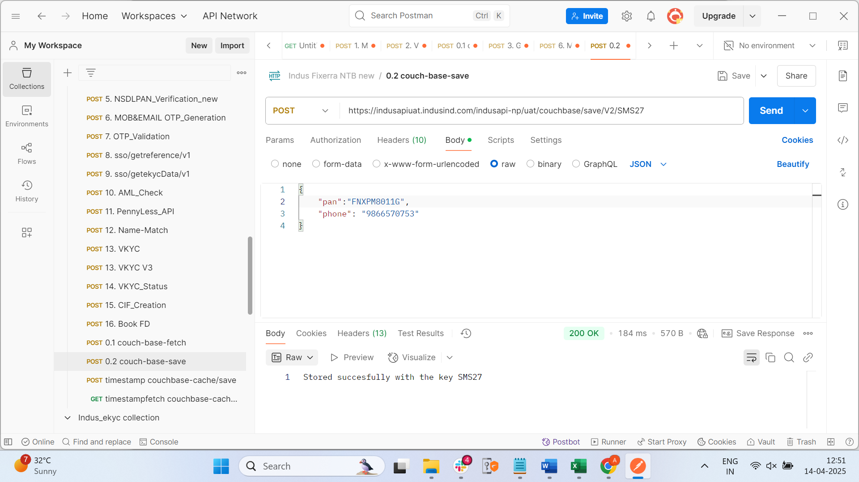

EKYC SSO generate :

Request :

{

    "apiKey": "2504140556E822",

      "sessionid": "8830d6e3-ec8c-4cc1-aced-51e46300f207",

    "requestUUID": "12445678901996",

    "uid": "619768639464",

    "AppRefNo": "SMS27"

}

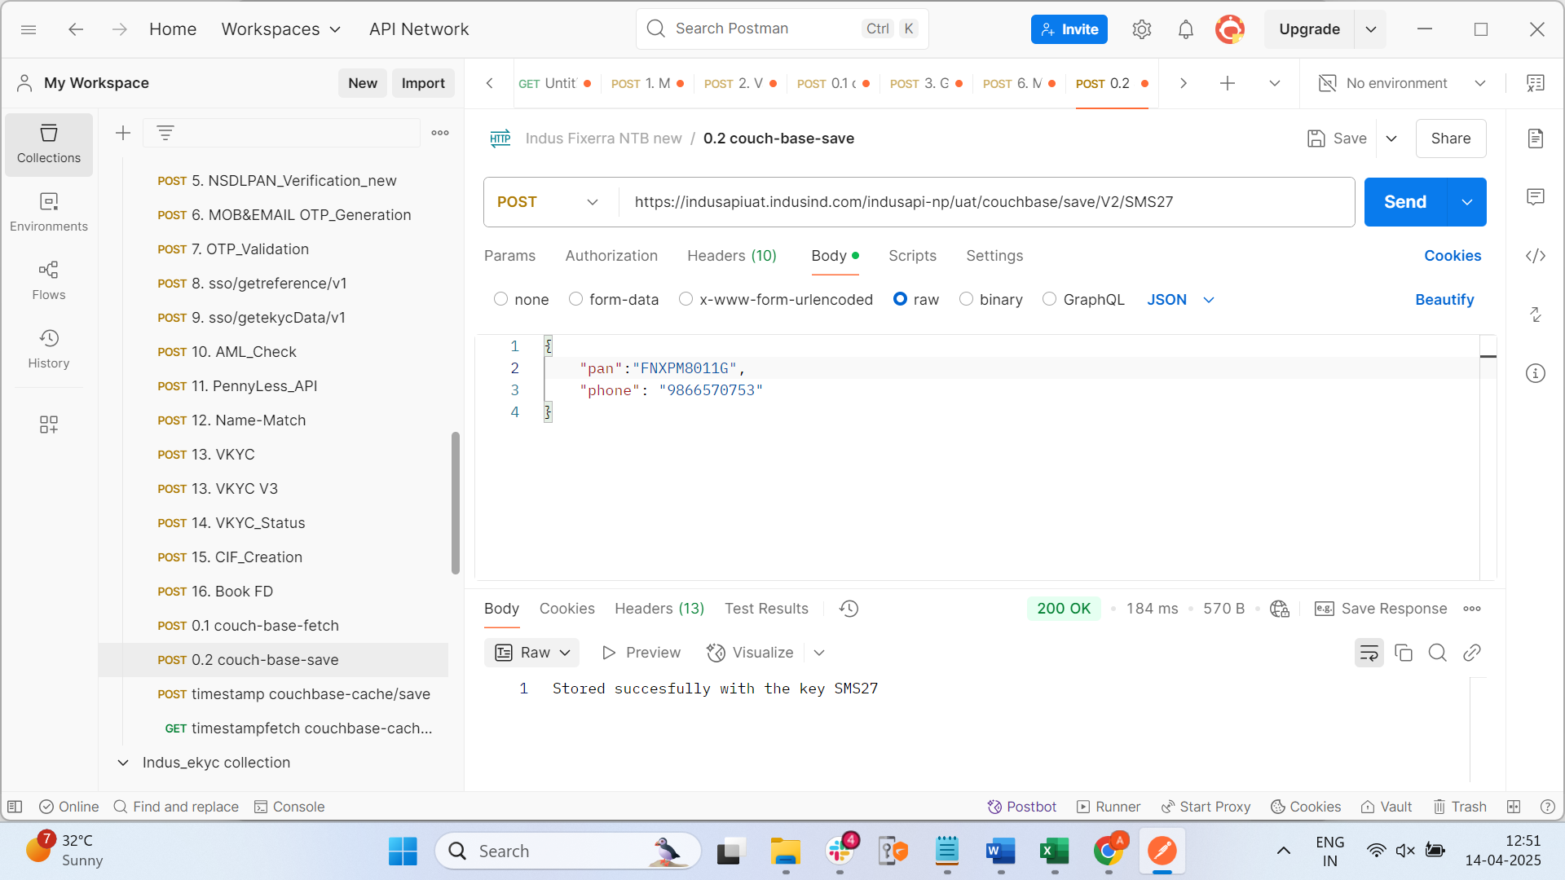

Response :

{

    "response": {

        "header": {

            "status": "success"

        },

        "body": {

            "pan": "9817060619768639464",

            "procCode": "140000",

            "transmDateTime": "0414072329",

            "stan": "543277",

            "localTransTime": "125329",

            "localDate": "0414",

            "acqID": "650002",

            "rrn": "510412543277",

            "responseCode": "00",

            "responseMsg": "Approved",

            "caTID": "register",

            "caID": "IUIA76232I02361",

            "catA": "IBL HOUSE ANDHERI      MUMBAI       MHIN",

            "txn": "543277"

        }

    }

}

Kycbyotpvalidation api : here wt ever the details u had sent in the ekyc sso generate send the same details here and then go to couch fetch and give ur api key then in the respone u will see all the details of urs .

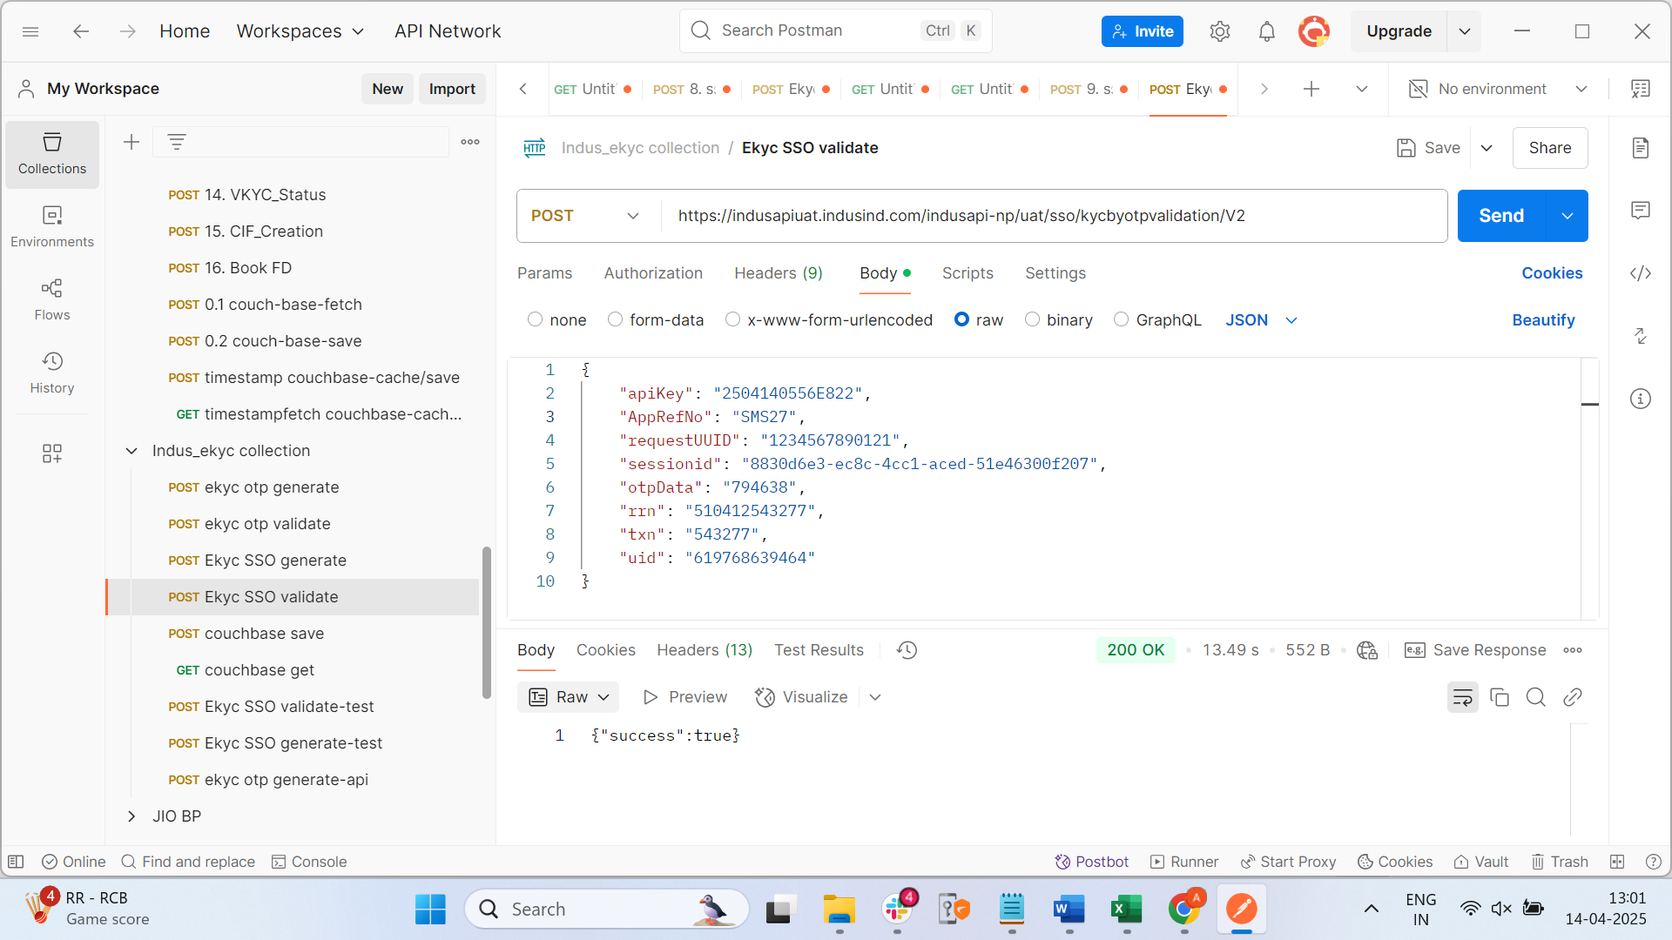

Request :

{

    "apiKey": "2504140556E822",

      "sessionid": "8830d6e3-ec8c-4cc1-aced-51e46300f207",

    "requestUUID": "12445678901996",

    "uid": "619768639464",

    "AppRefNo": "SMS27"

}

Response :

{“success”:”true”}

Couch fetch : give your API key then you will see all the details in couch

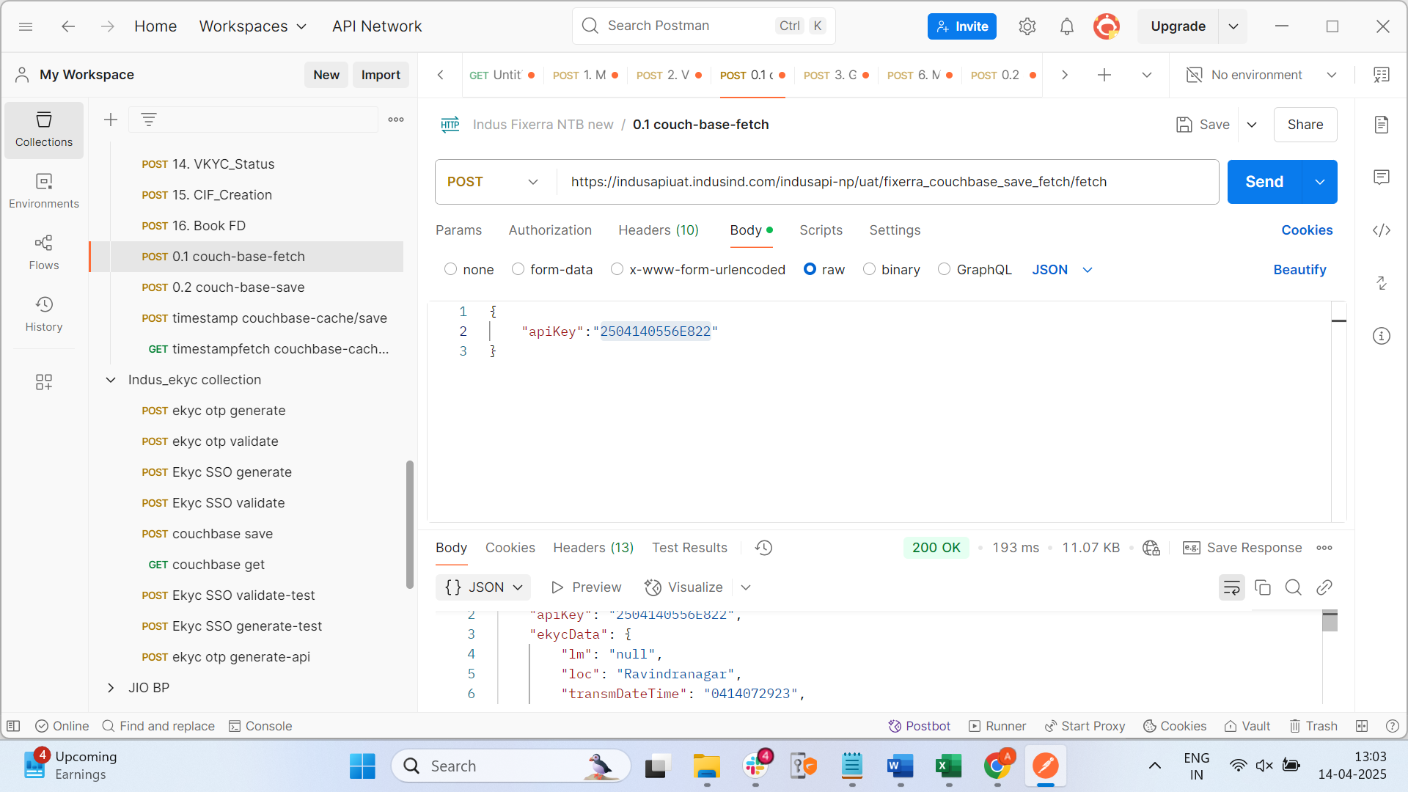

Response :

{

    "apiKey": "2504140556E822",

    "ekycData": {

        "lm": "null",

        "loc": "Ravindranagar",

        "transmDateTime": "0414072923",

        "gender": "F",

        "catA": "IBL HOUSE ANDHERI      MUMBAI       MHIN",

        "dist": "Adilabad",

        "house": "1-2-13/11/19",

        "responseCode": "00",

        "tkn": "01000531jl7yEyoZ7kJzcdAZGzLSYAeKForBEkLjBFATrojCLvllI9Sh7rFP+87JfLMVcHde",

        "street": "Ravindranagar",

        "caID": "IIUA76232I02361",

        "localDate": "0414",

        "state": "Telangana",

        "pan": "6071890619768639464",

        "Pht": "",

        "email": "null",

        "responseMsg": "Approved",

        "procCode": "130000",

        "vtc": "Adilabad",

        "txn": "UKC:543277",

        "co": "C/O: Mandha Varaprasad",

        "rescode": "00",

        "acqID": "200056",

        "rrn": "510412350282",

        "caTID": "register",

        "pc": "504001",

        "localTransTime": "125923",

        "phone": "null",

        "dob": "01-02-2001",

        "stan": "350282",

        "name": "Mandha Akhila",

        "po": "null"

    },

    "mobileNumber": "9866570753",

    "panname": "Mandha Akhila",

    "sessionId": "b1c8e756-211b-468c-911f-bceb195fc1ff",

    "panNumber": "FNXPM8011G",

    "documentFlag": "I",

    "panStatus": "True",

    "iWorkJourneyDesc": "Waiting for this journey to complete until the validation date for API key 2504140556E822.",

    "otpvalidationtimestamp": 1744610495,

    "sequence": "1.7",

    "uid": "619768639464",

    "dob": "01/02/2001",

    "Journey_Type": "NTB",

    "ekyctimestamp": 1744615774,

    "ekycStatus": "True"

}

AML Check API :

Request :

{

    "ruleName": "BRANCH_CUSTOMER_PARTNER_WL",

    "requestUUID": "2a6828f1756543309e859c7288b9a3ad",

    "name": "Akhila Mandha",

    "nationality": "INDIAN",

    "dob": "2001-02-01",

    "resAddrCity": "ADILABAD"

}

{

    "data": "eyJlbmMiOiJBMjU2R0NNIiwiYWxnIjoiQTI1NktXIn0.7OS2_PVh6foUL0i0ZG2IcKdadFKoAKHyZEv2rhY1SnNemEfpAC-X9Q.igaNTXdjYWdlaq8h.eVjuJepEeX_uYbiTwTP2jBl40IeCBFe300RZ6xx1A5VFKyrmCAitjjZ98zN9avoRibq4OQEkPYki8ZpCqUM3I-Pn9Rllc1zk5wK4byn-t4QbLpjeHRSfudsJiruGJPLsKHpbahgvip_pCdrpsoOCicX1U5II5G9ienguI-N9BOebWIakAaTMDqvObd3BZJ3bBKH-VCmnaU-hi-huqJWQfyJqzHelGCYNzTyAbDUD7mxcprYK50qRWR9vtoaS-s4H2gPkbRnh2Cj_rxjiWEsKNpFJvrKduFdoUerEAxxDzwjURQ.S7SUcf-qeek5iXRPHMm_kQ",

    "key": "eyJlbmMiOiJBMjU2R0NNIiwiYWxnIjoiUlNBLU9BRVAtMjU2In0.EtQKmByKxrtoSwvT7SBQTdD3D65xxRA2Tpah6VwCqiO9dgmuXS-6D2Hnny03w71Wuj1LoYBAcXGoenf37fdecBdelqs99yQPnoL9uusdjmU_H5f-mI90wJexcA1YKmovN2TGQAEDW5Il5bvqMPGZuy_ZMKAEiS5t29LC2bTqRxRxUSNsi-EAkmIZvy4mqFROGdO6qYk--yGtd1zQC70uIJ4DI73r39-BDdW2bLC8Jt3zeVVpg3LRvDGKMePkPHV5C4hsox3YLye4WysqjDJEyV4rD2MGz-qsva5zFySIRdlEic0EugWGnOPwf8vduArOuBACk7F-NKLvgDoK-VKocg.NzDk7JTgaH_Es0qu.XnxOgC_xQirwWyOqbO9YQ5Wr9F2YfKG1QZMMirXwAABkreHm8jn6AF2mw1P_B6n9ws-C-t2M14-RMT_WANUwNQ.fDZcjGYZwkEAuYc_cqmK-A",

    "bit": 0

}

Response :

{

    "decryptedData": "{\"WlMatch\":{\"status\":{\"status\":\"200\",\"errorDetails\":\"\"},\"matchedResults\":{\"total\":0,\"maxScore\":\"0.000\",\"matchedRecords\":{}}}}",

    "aeskey": "98a9a2d3e10dca8c1075084efdf8bf89722ae03823ad4341808fc01d8a9805d6"

}

Penny less api :

{

    "ApiKey": "2504140556E822",

    "createRealTimePaymentRequest": {

        "actionFlag": 1,

        "messageHeader": {

            "messageType": 9921,

            "channelId": "20001",

            "messageId": "DI06120623000064",

            "schemeId": 3,

            "requestType": 13,

            "serviceName": "RealTimePaymentService"

        },

        "remDetails": {

            "orderingCustomerAccount": "200000012441",

            "orderingCustomerName": "A S STOCK BROKING AND MANAGEM",

            "orderPartyReference1": "",

            "orderPartyReferenceType1": 1,

            "orderPartyReference2": "",

            "orderPartyReferenceType2": 2,

            "productType": 22

        },

        "pymntDetails": {

            "beneficiaryAccountType": "11",

            "beneficiaryAccount": "1234567890",

            "beneficiaryReference": "DI06120623000064",

            "transactionAmount": "0",

            "transactionCurrency": "INR",

            "beneficiaryBankReferenceType": 12,

            "beneficiaryBankReference": "ICIC0000001",

            "beneficiaryReferenceType": 1,

            "additionalBeneficiaryReference": "",

            "additionalBeneficiaryReferenceType": 2

        }

    }

}

Encry request :

{

        "data": "eyJlbmMiOiJBMjU2R0NNIiwiYWxnIjoiQTI1NktXIn0.PQUQnW33N2SBThOGJfBRPS-VZGfU9PXgd7NFBhHPyTpYMg9o15MO1w.lM92LVkSMcQ6-2wf.pvOwqKc4PfueFUNYVkV9td4edT8w0pJLA5o90J492sklQTyp947rfFQXwdRieocBuY5GraH138-SREHwTUETa17I8OnhA0g9YcqH034a0Mt6cwDAeaYQ-aXBPdp3b5fL1UyGhnqBdVH1yxjfCxVY8rz4-ePc0aEewzWKKoInHrKHO1GOMM7WFwWG0wpkeky83E6CwslzpANCs87H_7a0CPbJLmIssAzE5HYUvCLtFJX1fkvB8ygw2bjvQtRSUEcjMtPmns7HHEXucGh3JyKpFufQgXIO21027XxjUm_RfQLltsJHg570Tqa2QwjtiEMyvnphD72Pq72GL0_qOjJKzfaCayhuNo_f-U_wRepP7PQ8606wreJnhjzmjlGzIobOm3_U25puiOMSFtybOdlhtOpKEa68bmnX5FERMpFK6-UkQOxCVJLlji5p-5Z1Nx7Stss73IA5emTLukONYVW-NX8y_qg5bL7_I3X0XPZHNc6aVzX_iRrAyUtJjVzht7HlkPuIcxCNz6sedwJAuij8HARktoK8vNB4RHvviJGOYDCvWoz1L4hHMwwHHx-63iLZiHplvFlJ85O0u7XFvcaR1cdT9cHlMN4_iJOPKNgVvQdEAnsQbIJYbVfNnchwtbLw5AuFzwFMXP__FX6KrAWn158Z001uSKi1U6Rm1jmkCygbsx7wNwWNoI65LD7SefWHHUdj6Z_7kjzikDLiYYrHq_bai95xexaxhJG-4p5NqDnrfmUccmazmd6gJ1ngLU8-W9wCkWPXYzkJQvBg6tHjJABTVilwnqApK3qNdAo5WxbF3n3YlmlmDEp7v1Mpvpe0uF8UFdHMHJyhQ-9YR5iC7c7dXEWB1a9-_2faC_lU0bJl2v9D1QDm_5ACQuq5eOCiExQc_2I0tX7MhmPCHuZyFRCeCjZH7hjGePHI0AR5vtJJ0NUKp5TjGC1z3stK2-P1Lw14VwdpYnovpii7oFQHeGuWYKR0xfKskCg-Ead01DIC053auSGqnv5Xzj7zl99SYvBPsWWXVcOFeCR-h1GLxI2nEcQo9oJj8jgpY67RwiXV9hznTcmm58g8VB19cDIhmC5Vx5CNkPhyxQThnGyN14rNAnm8kcKdhSbUwDs1-xg2CbOZ-s3G1mMd_-Fj08U-eKyBVJx46VW9buFEnViZnWO1AhznV_XM5Zv6tnc3NNQBy1KeRSQ_HnkdpKjkChiYRaJOoqLLCYMs-fBc_g0xBTpQ5WzyzI3mxUHVghYDG3xvel4_iEFgoQKOomboRllhvadqo63JMq4MMEd3F8zP7QVgk-VnIvmS1aUsofpssRvJaMH05d4Cbtuk66nUUkUPfduN4A6rqYEq7Yk83NFZ4JmmCdrPF0cp0qUR_HXI5GCuU-JvnSMow-FCdIpfDXkd6NwlUIn7iB6CMTt_mvIl0k9RVmdcqZXbZmQ3NNgO_vCWiYRAF1jqhHkZNwl4v67WpeIEhuuinxGfCJ5AMSm5-2mIXYAHCz6GOWEmdmXgC6t4roWS9fFxPAEurfl9UKZWtIbiaTnq4EO9AGDoAfyL1O4okyJ-sse9gvFMdJDOviLs1W8dZGXyAgxQSSXNOI9-pGXgYNC8XnUPRzRlJKXc7OHIPnxmHYiZ-BYL2z6FP0uwrfVKe4m9cQdQ5qqhQEJvswl7sfETrfApt4AAN8KZh09GGQ.hNGQvcNUFTvz6pD1zLQrkg",

        "key": "eyJlbmMiOiJBMjU2R0NNIiwiYWxnIjoiUlNBLU9BRVAtMjU2In0.Y6WH_nJ6KPc4g8FekeI3lPaU6WjPJqE9PegKbydRxg-jmSzysus2EI0ohbh3l6RajA8iM6tluCkgBS4Ne6HWpXt-VeyGRFG28cRPdv9fkL1Hy1TrEP3EdkjdW1vWs0rNKlyubUuNJpwjab3j9IzaN9slJo_oSoFr2JJ36MNpoltch0z6VO2cfwpR5HyJ9RjPmAWw_5xsDRMHUBdr7QVK-NjiovijEeAlCajaG88rSFqK9sDc1etLVl_dvCNXZWHdN98QDCAZ_WrsWGr0mLsLVaeYF7HsvmmNPTI31PltA8toUgITF-f_jm86ouOoUeglKFXJjDkRcRbrKzlXx4BkxQ.H_LHiWWI6dlPWKvH.00VUrzyqzHREBsQceDdvLSywYuTne6j8LHygWbpdPuEjbWi5rbclzICakeAFLhekloB3nAHux6IlDcHMphdyVQ.KXZVVzjXG8KqzJFxqHWidQ",

        "bit": 0

    }

Response :

**{**

**"decryptedData": "{\"status\":400,\"error\":\"Internal Server Error\",\"message\":\"[752018 : Customer Type not defined in Finacle]\"}",**

**"aeskey": "7e4b1f48a6878f894e8a230fe04b01e83232a48a420250073c877d07eb37f31f"**

**}**

**Scenario: Online Payment Platform Verifying Vendor's Bank Account**

Imagine you run an **online payment platform** where businesses can make payments to vendors. You want to make sure that the bank account provided by each vendor is legitimate and properly matched to the correct individual or company.

**Traditional Method: Penny Drop Verification**

In a **traditional penny drop** method, when a vendor submits their **bank account number** and **IFSC code**, the platform would:

1. **Send a small amount** (a penny, or a few cents) to the vendor’s bank account to confirm that the account is valid.
2. The vendor would then have to **check their bank account**, find the small deposit, and **inform the platform** of the exact amount received.
3. Once the vendor confirms, the platform knows that the account is legitimate, and the transaction can proceed.

However, this traditional process takes time because:

* The penny drop transaction needs to be processed.
* The vendor must report the transaction.

In this method, a **small transaction** is used to verify the account, but it **delays** the verification and the overall payment process.

**Using a Penniless API: A Faster, More Efficient Way**

Now, let’s see how a **Penniless API** changes this process:

1. **Vendor Submits Account Details**:
   * Vendor **ABC Corp** wants to receive a payment, so they submit their **bank account number** (e.g., 1234567890) and **IFSC code** (e.g., XYZB0001234).
2. **API Request**:
   * Your platform sends a request to a **Penniless API**, providing the vendor’s **bank account number** and **IFSC code** for verification.
3. **Account Verification via Penniless API**:
   * The **Penniless API** directly queries the bank's system or a third-party service to verify whether the provided account is **active** and whether the **account holder's name** matches the one given (e.g., "ABC Corporation").
4. **Instant Response**:
   * The API quickly returns a **verification response**, showing:
     + Account holder: **ABC Corporation**
     + Account status: **Active**
     + Bank details: **XYZ Bank**
5. **Action**:
   * Based on the response from the API, your platform **immediately confirms** that the bank account is legitimate.
   * The payment is processed **instantly** without needing to wait for the penny drop to be confirmed by the vendor.

NameMatch Api :

{

    "task_id": "74f4c926-250c-43ca-9c53-453e87ceacd1",

    "group_id": "8e16424a-58fc-4ba4-ab20-5bc8e7c3c41e",

    "data": {

        "name1": "Akhila Mandha", // correct match

        "name2": "Mandha Akhila",

        "percentage": **false**

    }

}

{

    "data": "eyJlbmMiOiJBMjU2R0NNIiwiYWxnIjoiQTI1NktXIn0.p6GjtyeVlKch76VYmNScQqs5bEuVrZ-4-rWTZPhOV6a6UlEp96_gQA.2A_hYgvFz6Nsl7uH.wlh46lIweY4QHnTo7jVG8L0LFMmZ5SrnABg_6KLNzhd6SfYv6MDOS0shle0U5NP-_ABJsZvkVMUnN_KtaqIFrFAQez9FxJzOLmTr8uWpmTKbpIUYMv3hWqBr74NGuXeDe0iiZXf9Bg0z5wLAwYTSWrRxL_rdRNfWUGDVGPHWYcu_AMKB0xaFRYEirB1kxIibK8lRJ_o61xdSpp3Z8dO9nE6v3L5Zsk3iBtjQ-ruOtqLstpHYIPzNP5hJkbRoWXi5wGLr-zSkvLS2_vZmhWgKx5-zlmExZJ2TldhDtVXx0X4bxQRyumLehjI5EX-1cEmP.uMp782bnzHkKuAFWzZTSFA",

    "key": "eyJlbmMiOiJBMjU2R0NNIiwiYWxnIjoiUlNBLU9BRVAtMjU2In0.hOQ7y-y2K7B4yP9VT_Naxzavj691QrqHoUKbgrOrBuOiEJe8IyEOi8G3CsrVpYlAH8Y3SbI28AyJPP1qsIYDLFsvli-xBU-i-02q8N50Rs2NHogDUe0BqiNITELpfPJwVmG68rLnTJLcglZDbet3ms2uGyCjBobXRHvUe2c4uDBsfgpxRTla4u6If0ny5bCsm70d60JYYSAaGtzVc0GZoovH6Vj6OQLu5NHYAQlXYs6hbHQheunkOw3sZhYgqeablhSddR7z5yMHas552jz_---SvYfJ3UQdMeBi4jCzaE13zAFKlb4-360HC1CZzKFqJNR26rqqoM1j3gRUT3KZLA.Ize-gaDZ4slGtsRz.kRbQUxzujHW8zn1IaJ_LyrfNUoD0hZZFrrfYj-oTaWQCJbgGe5qbRcowNnvk-KoQG4nkJIL5KqjpUAhC7CwrKw.nhBrUhrkg9XMd_czXgq72g",

    "bit": 0

}

Respone :

{

    "decryptedData": "{\"action\":\"compare\",\"completed_at\":\"2025-04-14T14:49:25+05:30\",\"created_at\":\"2025-04-14T14:49:25+05:30\",\"group_id\":\"8e16424a-58fc-4ba4-ab20-5bc8e7c3c41e\",\"request_id\":\"6785826e-5816-42ac-b7ad-2dc960ecc523\",\"result\":{\"match_output\":{\"name_match\":5}},\"status\":\"completed\",\"task_id\":\"74f4c926-250c-43ca-9c53-453e87ceacd1\",\"type\":\"ind_names\"}",

    "aeskey": "2e59ca3c22f3fda43af20771405ab42d5f5fda6e8f655446612d0696c4543866"

}

**Video kyc :**

Request :





Response :

{

    "decryptedData": "{\"trackingId\":\"Test_Call_072556\",\"groupId\":132060,\"guestGroupId\":140382,\"organizationId\":3,\"displayName\":\"Praveenkumar\",\"flow\":\"Continuous\",\"product\":\"Fixed Deposit\",\"priority\":1,\"createdDate\":\"2025-04-14T09:42:11.274Z\",\"updatedDate\":\"2025-04-14T09:42:11.274Z\",\"status\":\"Open\",\"data\":[{\"name\":\"PANNumber\",\"value\":\"BXZPS7391P\",\"verifyWithPanCard\":true},{\"name\":\"NameAsPerNSDL\",\"value\":\"Praveenkumar\",\"verifyWithPanCard\":true},{\"name\":\"NameAsPerPanCard\",\"value\":\"Praveenkumar\",\"verifyWithPanCard\":true},{\"name\":\"Occupation\",\"value\":\"Salaried\",\"verifyWithCustomer\":true},{\"name\":\"Income\",\"value\":\"7Lakhs\",\"verifyWithCustomer\":true},{\"name\":\"Mobile Number\",\"value\":\"7666675990\",\"verifyWithCustomer\":true},{\"name\":\"NameAsPerAadharCard\",\"value\":\"Praveenkumar\",\"verifyWithCustomer\":true},{\"name\":\"AadhaarAddressLine1\",\"value\":\"S/O: Arumuganainar\"},{\"name\":\"AadhaarAddressLine2\",\"value\":\"50/4,South Street,\"},{\"name\":\"AadhaarAddressLine3\",\"value\":\"Seelathikulam,Radhapuram Taluk,Tirunelveli,Tamilnadu,India,627112\"},{\"name\":\"AadhaarAddressPincode\",\"value\":\"627112\",\"verifyWithCustomer\":true},{\"name\":\"CommunicationAddressLine1\",\"value\":\"9/107, 14th street\"},{\"name\":\"CommunicationAddressLine2\",\"value\":\"Gandhi Nagar, S.Kolathur,Kovilambakkam\"},{\"name\":\"CommunicationAddressLine3\",\"value\":\"Chennai\"},{\"name\":\"CommunicationAddressPinCode\",\"value\":\"600129\"},{\"name\":\"CommunicationAddressCity\",\"value\":\"Chennai\"},{\"name\":\"CommunicationAddressState\",\"value\":\"Tamilnadu\"},{\"name\":\"CommunicationAddressCountry\",\"value\":\"India\"},{\"name\":\"CommunicationAddressFlag\",\"value\":\"true\"},{\"name\":\"PAN&Aadhaarlinkage\",\"value\":\"linked\"},{\"name\":\"DateOfBirth\",\"value\":\"1989-12-24\",\"verifyWithCustomer\":true},{\"name\":\"EmailID\",\"value\":\"vkyctest@gmail.com\",\"verifyWithCustomer\":true},{\"name\":\"MaritalStatus\",\"value\":\"Married\"},{\"name\":\"Gender\",\"value\":\"Male\"},{\"name\":\"MothersName\",\"value\":\"Selvam\",\"verifyWithCustomer\":true},{\"name\":\"CityName\",\"value\":\"Tirunelveli\",\"verifyWithCustomer\":true},{\"name\":\"PANandAadhaarLinkage\",\"value\":\"PAN & Aadhaar are linked\"}],\"waitPageUrl\":\"https://videokycuat.indusind.com/openKYC/index.html?parentGrpId=132060&guestGrpId=140382&guestId=40646&orgId=3&cmp=true&locp=true&token=1tl6PGDgZZnnD5FShqgN1qisSCeKGMJ-8jFonKa-2os58RQQm9tnTkcSbKd88BcUadXBj0usZOaNpIPQNtTZ9FO_KPimEW3o1C_AcROc-6_TNxreajqQVSldj7s79lmCfsboVCvecwuX3s-9shRARHBC6BZY4I5wqpOkbl3Q!2&redirectUrl=https://www.indusind.com/in/en/personal.html\",\"videoKycStatus\":1,\"agentAvailabilityCheckStatus\":4,\"subProduct\":\"Salary\",\"communicationAddressMatchType\":0,\"id\":36613}",

    "aeskey": "492c411d7f1938abf5277d20b7de214eb35f68dedf0908473aa6c9234302d1ea"

}

-----Video kyc status API :

{

  "trackingID": "Test_Call_072556"

}

{

    "data": "eyJlbmMiOiJBMjU2R0NNIiwiYWxnIjoiQTI1NktXIn0.gxMCKReQt3hNet1LeaL2LyVX4fpUqskseEjs1nGgcBPrJ7IPLC8HNA.fMER67a2g1T9dnRn.0IP-mhSlkYoivIswy-qBLZewN6sAUxDmHv-rDVn8xLeXbN2fpO_M0Q.oOLbvhtWfhLLLjZPZftdZw",

    "key": "eyJlbmMiOiJBMjU2R0NNIiwiYWxnIjoiUlNBLU9BRVAtMjU2In0.k1-feAc7-szWRfUa35cBsL8uhQuxMLPKIUtRJiOO2WfX1-tK0UaG0nA5cprGljpXK50fvEd8OW9R9hVFAyxRGmI5a2tcZvFnCuZULqr-7qs-tgxS4FZaGOsZtyKXzhAFMoo6BAqZozzuO2eNAa8jnpt1qIWW3FUEvWyumfiBDia0Hjw1IjZSOsPtWyQpnTXi2gekoHl1LtMPe8cZRmg8AmrndcM02y8-6QVeIGdm720mamRb-jDVS2182Ra0ifgzy8_Mmd4VHsBkPBdgGWy0wj9pPMKXMIVy_WGDpyGBaBOteVj9giele1-PwgI89lC0KtEQBGQ2YfwPs6BNDZgNQQ.ADw5RNmWOWCqVzn-.znNPmN5rN4VeB6wilf5CS6vh9zJ2pHz3Ha1qYAXvKeQrUtbfhhk6n1AUnOmZ-3QnkZgIQaPdV3KKCPxSshQRlg.b_QyVuKNGHMW9Ae2FAi7hw",

    "bit": 0

}

Response :

{

    "decryptedData": "{\"trackingId\":\"Test_Call_072556\",\"groupId\":140382,\"displayName\":\"Praveenkumar\",\"flow\":\"Continuous\",\"product\":\"Fixed Deposit\",\"priority\":1,\"scpUrl\":\"https://videokycuat.indusind.com/kycscp/3LZ7nfAd6foFOMDMyO8KHkIq\",\"totalVideoCalls\":0,\"createdDate\":\"2025-04-14T15:12:11.000Z\",\"updatedBy\":{\"name\":\"user 7\",\"email\":\"user7@indusind.com\"},\"updatedDate\":\"2025-04-14T15:12:11.000Z\",\"status\":\"Open\",\"data\":[{\"name\":\"PANNumber\",\"value\":\"BXZPS7391P\",\"verifyWithPanCard\":true},{\"name\":\"NameAsPerNSDL\",\"value\":\"Praveenkumar\",\"verifyWithPanCard\":true},{\"name\":\"NameAsPerPanCard\",\"value\":\"Praveenkumar\",\"verifyWithPanCard\":true},{\"name\":\"Occupation\",\"value\":\"Salaried\",\"verifyWithCustomer\":true},{\"name\":\"Income\",\"value\":\"7Lakhs\",\"verifyWithCustomer\":true},{\"name\":\"Mobile Number\",\"value\":\"7666675990\",\"verifyWithCustomer\":true},{\"name\":\"NameAsPerAadharCard\",\"value\":\"Praveenkumar\",\"verifyWithCustomer\":true},{\"name\":\"AadhaarAddressLine1\",\"value\":\"S/O: Arumuganainar\"},{\"name\":\"AadhaarAddressLine2\",\"value\":\"50/4,South Street,\"},{\"name\":\"AadhaarAddressLine3\",\"value\":\"Seelathikulam,Radhapuram Taluk,Tirunelveli,Tamilnadu,India,627112\"},{\"name\":\"AadhaarAddressPincode\",\"value\":\"627112\"},{\"name\":\"CommunicationAddressLine1\",\"value\":\"9/107, 14th street\"},{\"name\":\"CommunicationAddressLine2\",\"value\":\"Gandhi Nagar, S.Kolathur,Kovilambakkam\"},{\"name\":\"CommunicationAddressLine3\",\"value\":\"Chennai\"},{\"name\":\"CommunicationAddressPinCode\",\"value\":\"600129\"},{\"name\":\"CommunicationAddressCity\",\"value\":\"Chennai\"},{\"name\":\"CommunicationAddressState\",\"value\":\"Tamilnadu\"},{\"name\":\"CommunicationAddressCountry\",\"value\":\"India\"},{\"name\":\"CommunicationAddressFlag\",\"value\":\"true\"},{\"name\":\"PAN&Aadhaarlinkage\",\"value\":\"linked\"},{\"name\":\"DateOfBirth\",\"value\":\"1989-12-24\"},{\"name\":\"EmailID\",\"value\":\"vkyctest@gmail.com\",\"verifyWithCustomer\":true},{\"name\":\"MaritalStatus\",\"value\":\"Married\"},{\"name\":\"Gender\",\"value\":\"Male\"},{\"name\":\"MothersName\",\"value\":\"Selvam\",\"verifyWithCustomer\":true},{\"name\":\"CityName\",\"value\":\"Tirunelveli\",\"verifyWithCustomer\":true},{\"name\":\"PANandAadhaarLinkage\",\"value\":\"PAN & Aadhaar are linked\"},{\"name\":\"WelcomeMessage\",\"value\":\"Welcome to Video KYC\",\"rnrEnable\":false,\"showWithCADoc\":false,\"isCustomFieldMandatory\":false}],\"documents\":[{\"id\":223021,\"fileName\":\"aadhaarPhoto.jpg\",\"fileSize\":\"123 KB\",\"basePath\":\"wa-uat-indusind-attachments\",\"filePath\":\"3/11/attachments/1325d36db34945c694e3260acac4b5ca1744623731451.jpg\",\"documentType\":\"AadharPhoto\",\"url\":\"https://videokycuat.indusind.com/owb/attachments/system/download/1325d36db34945c694e3260acac4b5ca1744623731451\",\"createdDate\":\"2025-04-14T15:12:11.000Z\",\"createdBy\":{\"name\":\"user 7\",\"email\":\"user7@indusind.com\"}}],\"subProduct\":\"Salary\",\"communicationAddressMatchType\":0,\"communicationAddressVerified\":\"None\",\"id\":36613}",

    "aeskey": "5fb6270715044fe80597cdc9d2eedd9e6e0cd1c2e05e7b14fd1afc3f733a97a7"

}

CIF Creation API :



Response :

{

    "decryptedData": "{\"success\":true}",

    "aeskey": "c5467be772b969a53a16084cb77d1197b4a2490b3e618f69fe9d1369c55f9ac4"

}

FD Booking API : keep the benificary account number which u kept in penny less api .

Request :

{

    "request": {

        "body": {

            "encFDbookingReq": {

                "city": "",

                "days": "211",

                "addr1": "52/a",

                "addr2": "52/a",

                "gCity": "",

                "acctId": "00993564615927",

                "custId": "68042102",

                "gAddr1": "",

                "gAddr2": "",

                "months": "0",

                "nomFlg": "N",

                "beneAdd": "52/a",

                "country": "",

                "opnDate": "30-12-2024",

                "relType": "",

                "beneName": "SHASHWAT SHAH",

                "branchId": "2022",

                "gCountry": "",

                "rtgsneft": "N",

                "schmCode": "PTDFX",

                "debitAcct": "00993562511551",

                "stateProv": "",

                "autoClsFlg": "Y",

                "autoRenFlg": "N",

                "gStateProv": "",

                "postalCode": "",

                "amountValue": "10000",

                "gPostalCode": "",

                "nomineeName": "",

                "beneIFSCCode": "HDFC0000009",

                "guardianCode": "",

                "guardianName": "",

                "phoneemailid": "916263915344",

                "beneAccountno": "1234567890",

                "prtNomRecpflg": "Y",

                "nomineeBirthDt": "",

                "nomineeMinorFlg": "N",

                "genLedgerSubHeadCode": "37030"

            }

        },

        "header": {

            "channelId": "FIX",

            "requestUUID": "146c5a42-8922-4e03-aa97-3aa68869fe26"

        }

    }

}

In Couch the response after the FD Booking will be :

{

**"PennylessBeneficiaryAccountNumber": "1234567890",**

    "FdRequest": {

        "request": {

            "body": {

                "encFDbookingReq": {

                    "country": "",

                    "city": "",

                    "gCountry": "",

                    "postalCode": "",

                    "relType": "",

                    "genLedgerSubHeadCode": "37030",

                    "beneIFSCCode": "HDFC0000009",

                    "beneName": "SHASHWAT SHAH",

                    "autoClsFlg": "Y",

                    "guardianName": "",

                    "rtgsneft": "N",

                    "custId": "68042102",

                    "nomineeMinorFlg": "N",

                    "opnDate": "30-12-2024",

                    "gStateProv": "",

                    "prtNomRecpflg": "Y",

                    "phoneemailid": "916263915344",

                    "beneAccountno": "1234567890",

                    "branchId": "2022",

                    "months": "0",

                    "addr2": "52/a",

                    "addr1": "52/a",

                    "acctId": "00993564615927",

                    "nomineeBirthDt": "",

                    "schmCode": "PTDFX",

                    "gPostalCode": "",

                    "nomineeName": "",

                    "stateProv": "",

                    "amountValue": "10000",

                    "autoRenFlg": "N",

                    "nomFlg": "N",

                    "days": "211",

                    "gCity": "",

                    "guardianCode": "",

                    "gAddr2": "",

                    "debitAcct": "00993562511551",

                    "beneAdd": "52/a",

                    "gAddr1": ""

                }

            },

            "header": {

                "requestUUID": "146c5a42-8922-4e03-aa97-3aa68869fe26",

                "channelId": "FIX"

            }

        }

    },

    "apiKey": "2504140556E822",

    "ekycData": {

        "lm": "null",

        "loc": "Ravindranagar",

        "transmDateTime": "0414072923",

        "gender": "F",

        "catA": "IBL HOUSE ANDHERI      MUMBAI       MHIN",

        "dist": "Adilabad",

        "house": "1-2-13/11/19",

        "responseCode": "00",

        "tkn": "01000531jl7yEyoZ7kJzcdAZGzLSYAeKForBEkLjBFATrojCLvllI9Sh7rFP+87JfLMVcHde",

        "street": "Ravindranagar",

        "caID": "IIUA76232I02361",

        "localDate": "0414",

        "state": "Telangana",

        "pan": "6071890619768639464",

        "Pht": "",

        "email": "null",

        "responseMsg": "Approved",

        "procCode": "130000",

        "vtc": "Adilabad",

        "txn": "UKC:543277",

        "co": "C/O: Mandha Varaprasad",

        "rescode": "00",

        "acqID": "200056",

        "rrn": "510412350282",

        "caTID": "register",

        "pc": "504001",

        "localTransTime": "125923",

        "phone": "null",

        "dob": "01-02-2001",

        "stan": "350282",

        "name": "Mandha Akhila",

        "po": "null"

    },

    "mobileNumber": "9866570753",

    "FdBookingFlag": "FALSE",

    "panname": "Mandha Akhila",

    "vkycflag": "True",

    "sessionId": "b1c8e756-211b-468c-911f-bceb195fc1ff",

    "panNumber": "FNXPM8011G",

    "documentFlag": "I",

    "panStatus": "True",

    "iWorkJourneyDesc": "Waiting for this journey to complete until the validation date for API key 2504140556E822.",

    "otpvalidationtimestamp": 1744610495,

    "sequence": "1.12",

    "uid": "619768639464",

    "NameMatchName1": "Akhila Mandha",

    "NameMatchName2": "Mandha Akhila",

    "dob": "01/02/2001",

    "Journey_Type": "NTB",

    "ekyctimestamp": 1744615774,

    "NameMatchScore": 5,

    "ekycStatus": "True"

}

**This is the url , keep this url in the browser :**

<https://srvcportaluat.indusind.com/SSO/?token=5df786d3-051d-4a07-b91d-f34b8acbe82b&client_id=f89c25480aa01ef07b2da59dceccaef6&app_id=5b2fdd73-0e0e-482c-a000-17ec067e3ea1&AppRefNo=a39609d6-7af6-426b-ba2f-08858fb7095a&apiKey=25042406028912>

this page will be loaded :

